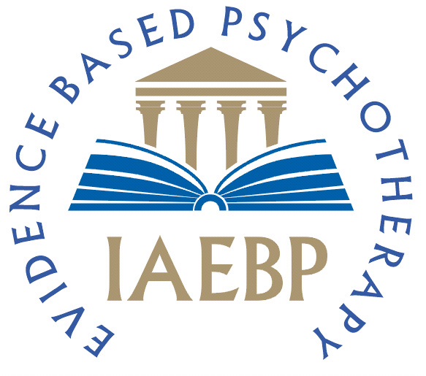
International Association for Evidence Based Psychotherapy
Introductory training day in Coherence Therapy - Watford
5th March 2016 with Paul Sibson

BOOKING FORM

Please complete the booking form and return it electronically to: admin@iaebp.com

Workshop Dates and Fees  10.00 am to 5.30 pm  ONE HOUR LUNCH BREAK  TEAS, COFFEES, WATER, BISCUITS AND LUNCH WILL BE PROVIDED | Introductory training day in Coherence Therapy - Watford  5th March 2016 £135.00 □
NAME (please print
PROFESSIONAL QUALIFICATION  ACCREDITING ORGANISATION  PREVIOUS COHERENCE THERAPY WORKSHOPS IF ANY  (please print) | DATE/S ATTENDED: VENUE:
POSTAL ADDRESS
(please print)
CONTACT TELEPHONE NO.
EMAIL ADDRESS
(please print)
Payment Method | □ By cheque payable to J.MANNING and sent to J Manning, IAEBP, 1 Castle Road, Southampton SO18 1QP  □ By bank transfer (payment details on LOGISTICS page below)  □ By PayPal payment to paypal@ieabp.com
Receipt - sent electronically | □ Yes, I would like a receipt sent electronically: Yes / No

Signature Date
LOGISTICS

PAYMENT METHODS

There are three payment methods available:-

BANK TRANSFER – To make payment by bank transfer, please use the following account details using your name as the reference:-

Bank: HSBC
Account Name: J Manning Esq
Account Number: 41022792
Sort Code: 40-42-17

CHEQUE - Cheques are to be made out to J.MANNING and sent to J Manning, IAEBP, 1 Castle Road, Southampton SO18 1QP
PAYPAL - PayPal payments can be made to paypal@iaebp.com

CANCELLATION POLICY - Payment is fully refundable if a cancellation is made in writing and received 8 weeks (January 9th 2016) prior to the workshop. Regrettably after January 9th 2016 due to speakers’ travel costs and administration arrangements refunds are not available under any circumstances.

PLEASE NOTE YOUR BOOKING IS NOT CONFIRMED UNTIL PAYMENT IS RECEIVED IN FULL

VENUE The workshop will take place at the following address which is on the main A41 road around Watford and just south of M1 junction 5:

Hilton Hotel
Elton Way
Watford
WD25 8HA
Tel. 01923-235-881

CERTIFICATES OF ATTENDANCE (7 hours credit) are available for all participants at the end of the workshop

WHAT TO BRING

Clothing – Comfortable, relaxed clothing is all that’s needed.

Refreshments - Tea/coffee and snacks will be provided in the breaks. There will also be a full buffet lunch.

Stationery – All you will need is a notepad and pen. You will be provided with all other materials.

WE LOOK FORWARD TO SEEING YOU THERE!!

